Gender Bias in Physician Reviews and its effect on provision of sanction

Abstract

This paper analyzes the patient reviews of physicians using a probabilistic joint model of topic and sentiment based on factorial Latent Dirichlet Allocation model (Paul and Dredze 2012). Using this model, we analyze about 140000 reviews obtained from MDreviews.com that get grouped automatically into topics. Further, with the help of another dataset that helps identify the gender of the physicians, we are able to identify gender bias that occurs in those reviews. The proposed model, when compared to baseline models performs better for this task such that it conclusively identifies the perplexity of sentiment classification amongst the genders of different physicians. We also present the most frequent and representative words with respect to positive and negative sentiment by means of different lexicons.

Introduction and motivation

According to a report that was conducted by a medical online review firm, 77% of the patients read online reviews as the first step in order to find their physician. The amount of such patients using the web as leverage for their personal care has increased by 68% over the years since 2013. This increase in usage of internet, shift in consumption of the health information has useful value to patients. Segal et al. (2012) has shown online doctor reviews can track quality of care. This kind of information seemed not only for people in terms of patient care but it also improved the brand value of the physicians and their outlook.

This analysis of physician comment content with the help of their respective personal information like gender, their department, their rating and even their geography helps in establishing the sentiment analysis adding their value as means of additional features in the model. Further, with the help of data that helps whether or not, the physician gets a sanction, we are able to establish a relation between the former and the sentiment of the reviews. Existing explorations of online reviews and papers on them illustrate ways in which administrators at clinics and physicians’ offices can utilize sentiment analysis and time-to-next-complaint methods to analyze web-based patient comments (Hopper and Uriyo 2015). This paper will additionally use gender and other aspects to analyze and elucidate the content of online physician reviews.

Data

To this, we propose a joint probabilistic model that captures both the sentiment and aspects latent in the free text of online provider reviews. The main objective is to elucidate how gender of the physician affects consumer sentiment regarding interactions with their physician and predict how sentiment affects whether or not the physician gets sanction. The data comprises of about 140000 online doctor reviews, which is available over MDreviews.com website. Data comprises of features like id, ratings, department of the physician, state in which he/she operates in, average knowledge rating, average helpable nature rating, average punctuality rating, sanction availability and the review itself. Our aim is to ease out the text associated with strong sentiment in the reviews along these aspects to illustrate the factors that most influence patient satisfaction. We develop a novel probabilistic generative model based on Factorial Latent Dirichlet Allocation (f-LDA) that exploits both the review ratings and a set of manual annotations that basically uncover negative and positive sentiment along various aspects of health care

Further, after identifying the topics of the sentiments, we then basically take the sentiment as a feature to the prediction model that is built in order to identify the sanction availability for the particular physician. This model is built by means of using a logistic regression model that also takes gender into account, as a result of which we are also able to identify the gender bias in reviews.

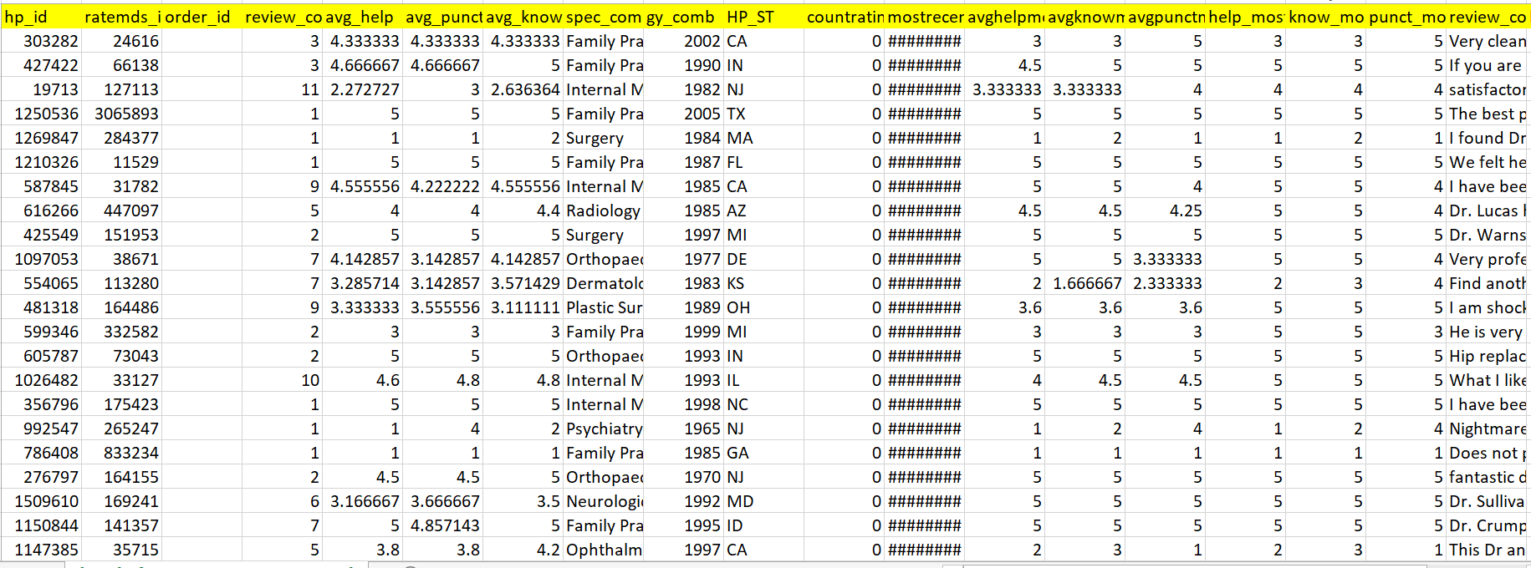

Further, we use two datasets in this work. The first is a set of online reviews that was extracted from the MDreviews.com website and the second dataset comprises of the respective genders of doctors that are relative to the id from the first data set. Our dataset covers just about the same number of unique doctors whose reviews contain free text and requires cleaning in order to proceed further.

Related work

There has been a flurry of recent research concerning online physician rating websites (Segal et al. 2012; Emmert, Sander, and Pisch 2013; Lopez´ et al. 2012; Galizzi et al. 2012; Ellimoottil et al. 2012). One of the most interesting findings was by Lopez´ et al. (2012) where reviews often concern aspects beyond the patient-doctor relationship (e.g., office staff). They also found that bedside manner was a key to successful patient-doctor interactions.

Segal et al. (2012) analyzed the relationship between surgeons performing many operations and online reviews. Surgeons who performed more procedures tended to have better clinical outcomes and safety records and found that they could identify high-volume surgeons using online reviews, and that high-volume surgeons tended to receive more praise.

Brody and Elhadad (2010) explored “salient aspects” in online reviews of healthcare providers via Latent Dirichlet Allocation (LDA) (Blei, Ng, and Jordan 2003). They based reviews according to provider specialty and discovered aspects on each of the specialties. Moreover, they used a variant of LDA, we explicitly model the topic and sentiment jointly to discover salient factors with respect to negative and positive reviews across different aspects of treatment.

There has been some work on the task of aspect based sentiment summarization (Mei et al. 2007; Titov and McDonald 2008) where reviews contained positive or negative sentiment. Generally, this is with respect to the overall sentiment in a document whereas aspect sentiment focuses on latent sentiment on specific aspects like a restaurant lauding the food but lamenting on the service

Further, Adams et. Al 2007, in their paper, for female doctors recall more patient cues overall, particularly about history presentation, and particularly amongst women. Male doctors appear less affected by patient gender but both male and especially female doctors take more account of male patients’ age, and consider more age‐related disease possibilities for men than women. Thus this kind of explains the gender bias where the paper mainly focuses mainly on the coronary heart disease which is a part of medicine

An advantage of the LDA’s sentiment analysis and prediction using that sentiment is that we normally use it as a jointly model for the interaction of topic and sentiment together; that is, we model that some words are associated with the particular pairing of a topic category and sentiment polarity value. More about it will be explained in the details below

A Joint Topic-Sentiment LDA model

We propose a novel topic-sentiment model based on fac-torial LDA (Paul and Dredze 2012). Our approach jointly models topic and sentiment, allowing us to analyze the pos-itive and negative words associated with specific topics such as interpersonal manners or technical competence. We first review factorial LDA and then describe two extensions to tailor the model to our doctor review analysis. First, we use the approach of Paul and Dredze (2013) to leverage annota-tions provided by content experts, thus exploiting these for larger-scale inference. Second, we introduce a novel exten-sion to the model that incorporates tangential but informa-tive user ratings to guide the model.

References

Blei, D.; Ng, A.; and Jordan, M. 2003. Latent dirichlet allocation.
The Journal of Machine Learning Research 3:993–1022.

Brody, S., and Elhadad, N. 2010. Detecting salient aspects in online reviews of health providers. In AMIA.

Eisenstein, J.; Ahmed, A.; and Xing, E. P. 2011. Sparse additive generative models of text. In ICML.

Ellimoottil, C.; Hart, A.; Greco, K.; Quek, M. L.; and Farooq, A.

2012. Online reviews of 500 urologists. The Journal of Urology.

Emmert, M.; Sander, U.; and Pisch, F. 2013. Eight questions about physician-rating websites: A systematic review. Journal of Medical Internet Research 15(2):e24.

Fox, S., and Duggan, M. 2013. Health online 2013. Technical report, Pew Internet and American Life Project.

Galizzi, M. M.; Miraldo, M.; Stavropoulou, C.; Desai, M.; Jay-atunga, W.; Joshi, M.; and Parikh, S. 2012. Who is more likely to use doctor-rating websites, and why? A cross-sectional study in London. BMJ open 2(6).

Lopez,´ A.; Detz, A.; Ratanawongsa, N.; and Sarkar, U. 2012. What patients say about their doctors online: A qualitative content anal-ysis. Journal of General Internal Medicine 1–8.

Lu, Y.; Zhai, C.; and Sundaresan, N. 2009. Rated aspect summa-rization of short comments. In WWW.

Mei, Q.; Ling, X.; Wondra, M.; Su, H.; and Zhai, C. 2007. Topic sentiment mixture: modeling facets and opinions in weblogs. In WWW.

Pang, B., and Lee, L. 2004. A sentimental education: Sentiment analysis using subjectivity summarization based on minimum cuts. In ACL.

Paul, M., and Dredze, M. 2012. Factorial LDA: Sparse multi-dimensional text models. In NIPS.

Paul, M. J., and Dredze, M. 2013. Drug extraction from the web: Summarizing drug experiences with multi-dimensional topic mod-els. In NAACL.

Segal, J.; Sacopulos, M.; Sheets, V.; Thurston, I.; Brooks, K.; and Puccia, R. 2012. Online doctor reviews: Do they track surgeon volume, a proxy for quality of care? J Med Internet Res 14(2).

Titov, I., and McDonald, R. 2008. A joint model of text and aspect ratings for sentiment summarization. ACL 51.

58

